RIM 2025
Information on Comparison measurement of radon in soil gas at radon reference sites in the Czech Republic

1. General information – purpose of measurement
Radon comparison measurements at radon reference sites serve for verification of field radon (²²²Rn) measurements performed by single organizations. Radon comparison measurement tests the calibration of the instrument, the technique of soil gas sampling, soil gas transfer into the detection chamber, radon-measuring procedure and stability of field measurements, elimination of thoron (²²⁰Rn), and data processing. Tests are based on the comparison of numerically reported radon (²²²Rn) activity concentration in soil gas (kBq/m³) by specified organization with other participants of comparison measurement and with the databases of two reference sites.

2. Term of radon comparison measurements RIM 2025
International Radon Comparison Measurement (RIM) at radon reference sites 2025 will be held on the 15 September 2025.

3. Place of radon comparison measurements RIM 2025
Radon comparison measurements RIM 2025 will be held at two radon reference sites Cetyne and Buk in the Czech Republic. Faculty of Science of the Charles University in Prague is the administrator of radon reference sites. Contact: milan.matolin@natur.cuni.cz

The radon reference sites are 60 km SW of Prague (Praha) near the city Milín (Fig. 1) in the Czech Republic. The natural radon reference sites Cetyne and Buk, have been established in 2000, they are located on meadows, and are accessible for cars. Each reference site implies 10 stabilized stations marked by numbers. Single reference sites differ in radon activity concentration in soil gas, the radon distribution within the reference site is relatively homogeneous, and thickness and permeability of soils enable soil gas sampling at the reference depth of 0.8 m. Geological setting at radon reference sites was investigated by several geophysical methods. Temporal radon variations are recorded since the year 2000. There is no electrical power supply at radon reference sites, however a power supply generator can be provided on the request (See Questionnaire).

Table 1. Characteristic of radon reference sites

Reference  site | c_{A} ²²²Rn (kBq/m³) | Permeab. of soil | Rock | Soil | U (ppm) | Terrain | Access for cars
Cetyne | 32 | L,(M),H | orthogneiss | SL | 2.0 | Meadow | +
Buk | 146 | H | granodiorite | LS | 3.6 | Meadow | +
L – Low, M – Medium, H – High
SL – sandy loam, LS – loamy sand.

4. Radon comparison measurement RIM 2025
Radon comparison measurement at reference sites is organized for a group of participants. Each participating organization measures radon (²²²Rn) at 10 stabilized stations of each reference site by its own technique. Soil air is sampled from the reference depth of 0.8 m at a allocated point for each participant near to each stabilized station. Measurement at two radon reference sites Cetyne and Buk at RIM 2025 is planned for 1 day. Each organization reports data on the activity concentration of radon in soil gas expressed in three valid digits (XX.X kBq/m³) at single stations of reference sites filled in a provided form (Report). The form with results (Report) should be mailed to the Administrator: milan.matolin@natur.cuni.cz by 30 September 2025.

5. Tests of radon comparison measurement
Tests are based on comparison of radon data reported by participating organization with radon data of the group, and with radon data of a database of the respective reference site. The computer programme TestMOAR evaluates the reported radon data. Three tests based on statistics were developed and programmed by the Institute of Applied Mathematics and Computer Technique, Faculty of Science, Charles University in Prague. Test No. 1 calculates differences between radon activity concentration at single stations (N = 10) of a reference site, reported by the participant, and a median of radon data reported by the group, which measured radon at identical stations in the same day of measurement. Test No. 2 determines the regression y = a + bx between radon activity concentration at all measured stations of the two reference sites (N = 2x10 = 20 stations) reported by tested participant (y), and median (x) of radon data for relevant identical stations reported by the administrator and all other participants measuring the same day. Test No. 3 is the comparison of the mean radon activity concentration in soil gas (N = 10) reported by the participant for a single reference site with the mean radon activity concentration in the database of the reference site. At present (2025), the database of each radon reference site comprises 350 data sets of successful measurements of organizations during the period 2000 – 2024. In order to eliminate temporal radon variation, Test No. 3 works with standardized (normed) radon data. The testing criterion (relation of normed mean radon activity concentration by participant/normed mean radon activity concentration of reference site database), has the ideal value equal to one. Test No. 3 accepts deviations of standardized radon data in the range 0.7 - 1.3 (30 % relative deviation). Test No. 3 is performed for each reference site separately. Computer programme TestMOAR accepts reduced number of entry radon data observed at a reference site. Results of tests will be anonymous; each organization will be denoted by a code.

6. Results of radon comparison measurement RIM 2025
Each participant of RIM 2025 will receive his Protocol of assessment introducing numerical results of Tests No. 1, 2 and 3, a graph showing mean radon data of single participating organizations (organizations marked in codes) and the table with the numerical means of all participants at two reference sites. Protocols of assessment and results of intercomparison measurement RIM 2025 will be available after all participants will pass over their data on measured radon activity concentration at reference sites. Protocols of assessment will be mailed by the e-mail to reported e-mail addresses of each participating organization in October 2025.

7. Transport Prague – reference sites
Organizers of the workshop on request will provide transport Prague - reference sites (See Questionnaire).

8. Preliminary time schedule
Monday, 15 September 2025
8.00 Departure from Prague
9.30 - 12.30 Measurement at reference site Cetyne
13.30 - 16.00 Measurement at reference site Buk
16.00 Departure to Prague
Note: Refreshment (tea, coffee, beer, sausages) will be available at reference site Buk during the whole radon comparison measurement.

Accommodation (If you prefer to start your visit to the Czech Republic near the reference sites, not in Prague): Suitable accommodation, just near to the area of radon reference sites, is available in “Hotel u Milina” (www.hotelumilina.cz).

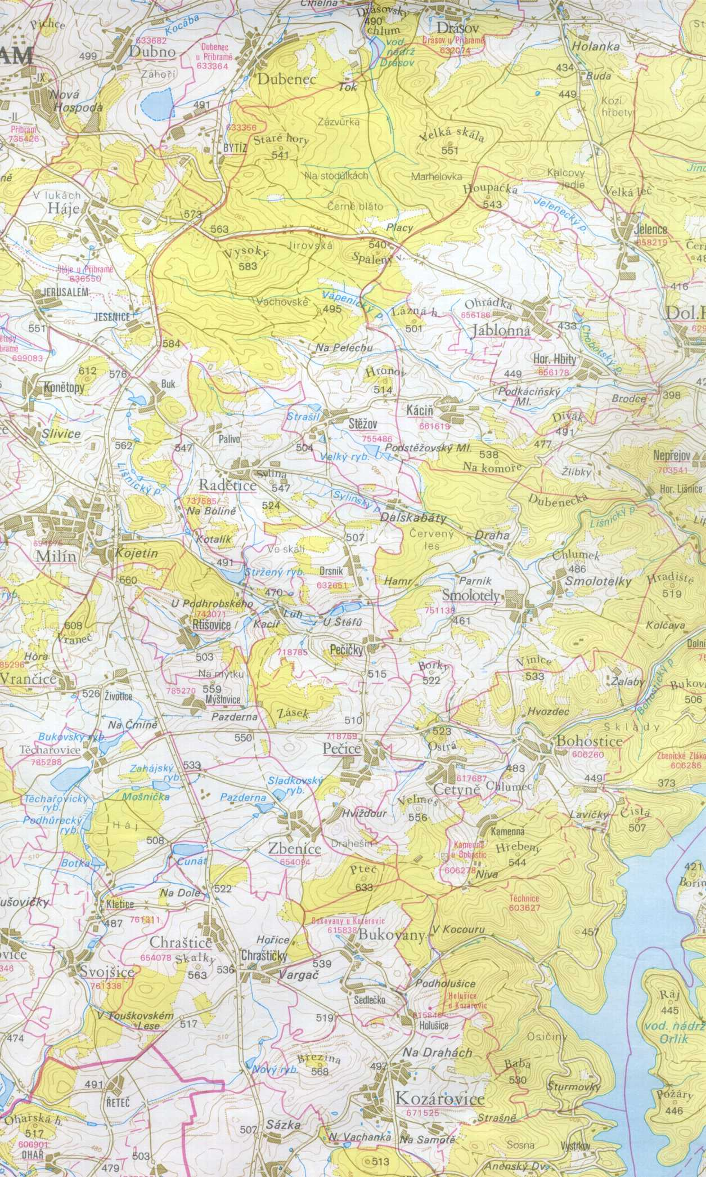
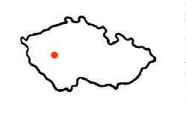

Praha
Přibram

Buk
Loc: 49°38'44.851"N, 14°3'50.597"E

Hotel
U Milína
www.hotelumilina.cz

Cetyne
Loc: 49°36'24.412"N, 14°7'17.033"E

Location of radon reference sites Cetyně, Bohostice and Buk, Czech Republic

Location of radon reference sites Cetyne and Buk, Czech Republic

Location of radon reference sites Cetyne and Buk, Czech Republic
REPORT

on Radon Comparison Measurement RIM 2025 at radon reference sites
in the Czech Republic

Name of organization:
Country:
E-mail of contact person:

Date of measurement:
Operator (name):

Soil gas sampling
Type of sampling probe (“Neznal” probe, packer probe, other sampling):
Method of soil gas sampling (grab sampling/janette, continuous pumping, other):

Radon detection method (ionization chambers, Lucas cells, semiconductor detector, track etch):

Model of instrument:
Serial No.:
Date, city and country of calibration:

Table Radon (²²²Rn) activity concentration determined at radon reference sites

 | Cetyne |  | Buk
 | Depth | c_{A} | Depth | c_{A}
Station No. | m | kBq/m³ | m | kBq/m³
1
2
3
4
5
6
7
8
9
10
Depth = depth of soil gas sampling

Please fill in the form by computer in Word editor and send to the e-mail address: milan.matolin@natur.cuni.cz

